Countess Quanta Robot User Manual v1.0

Yin Shi

ECE 578

Perkowski

April 30, 2014

Contents

**How to set up hardware :** 2

**Kinect set up** 2

**Pololu servo controller setup** 4

**Digital Photo Frame setup :** 6

**Power for the servo :** 9

**How to use software :** 12

**Run the software :** 12

**Implement the scenario for the robot :** 15

**Grammar for robot :** 18

**Motion sequence for robots :** 19

**Change Servo default parameter:** 21

**Gesture recognition :** 21

**Also change some servos:** 23

**How to set up hardware :**

## **Kinect set up**

Step 1:

Connect Kinect Sensor cable with Kinect power adapter

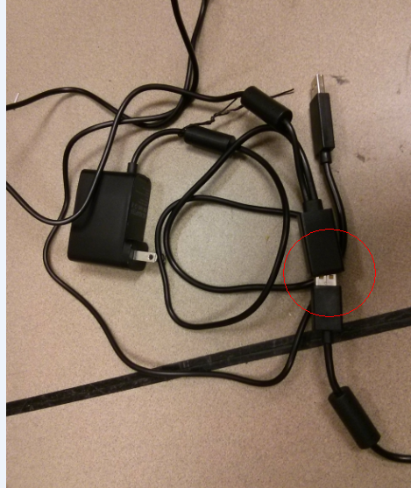

Step 2:

Connect Kinect Sensor data usb port with laptop

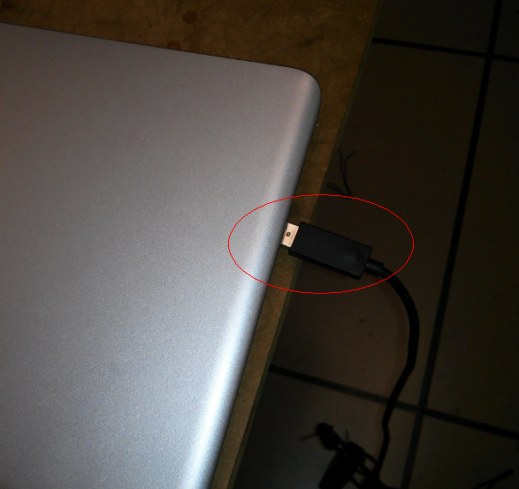

## **Pololu servo controller setup**

Step 3:

Connect pololu servo controller to the laptop :

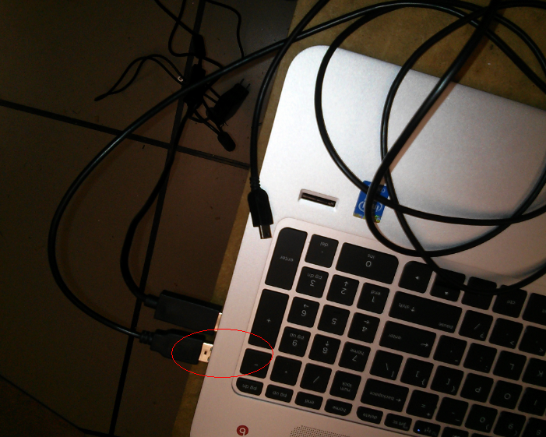

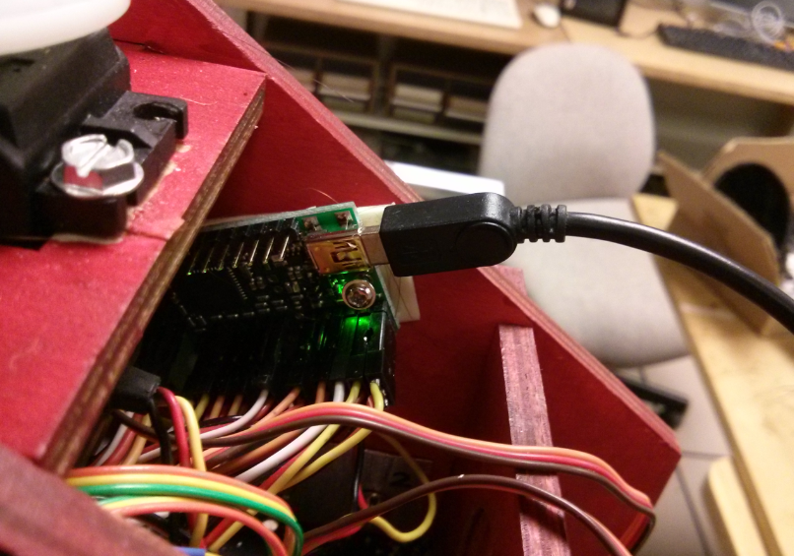

## **Digital Photo Frame setup :**

Connect the power adapter :

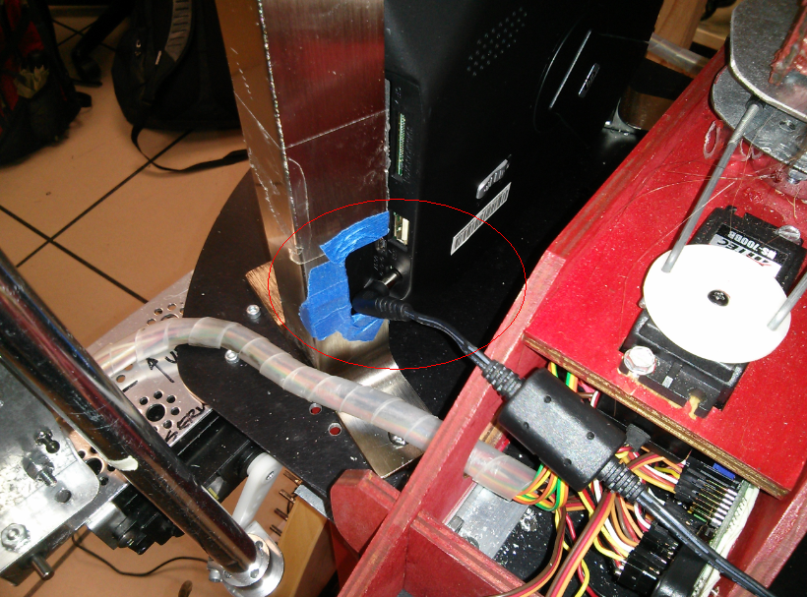

Power on the back :

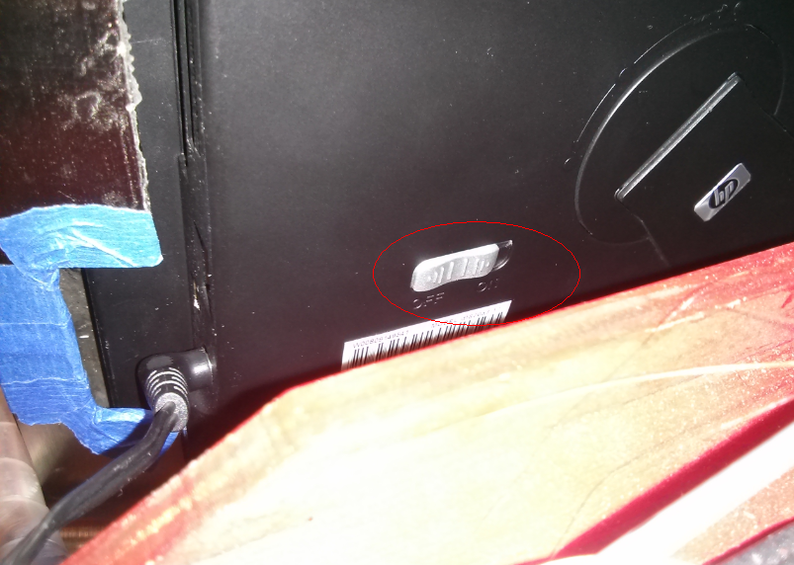

You can use either USB flash , SD card or connect MiniUSB port to laptop , here use USB flash, download the photo to the usb flash , then connect to the photo frame , and the photo frame will display the photos in the usb flash.

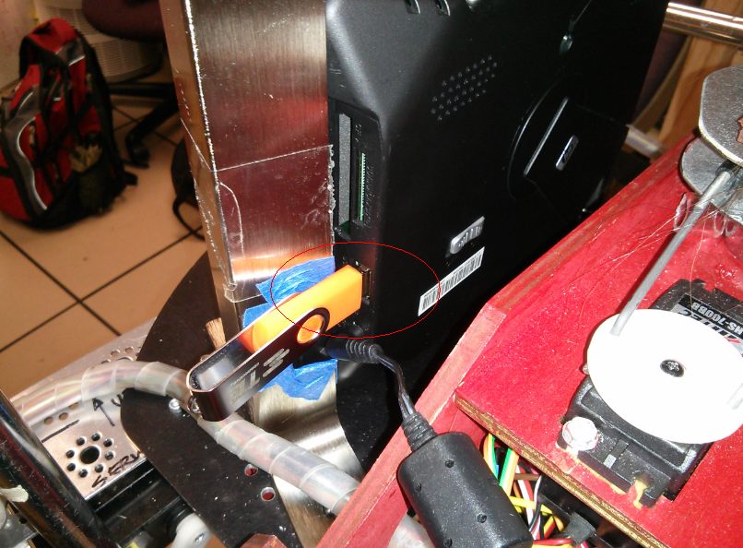

## **Power for the servo :**

Swith to the On for starting the system

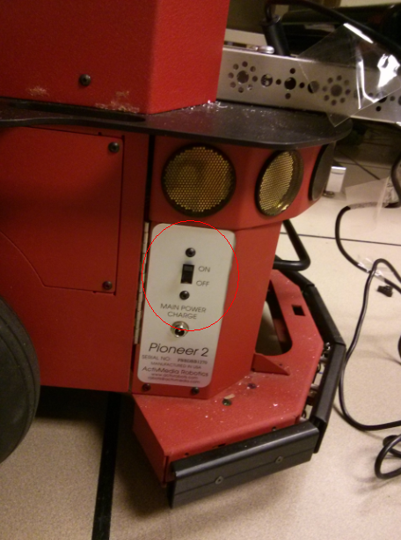

If the voltage is too low for the battery , connect the charger to the power source:

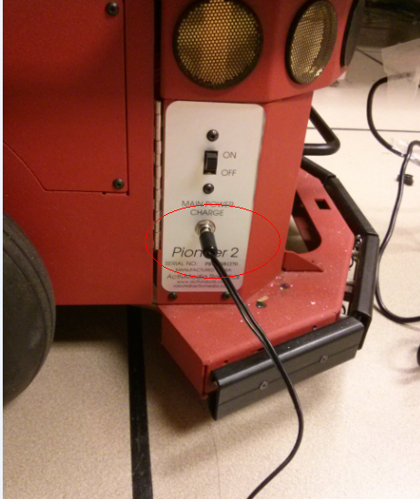

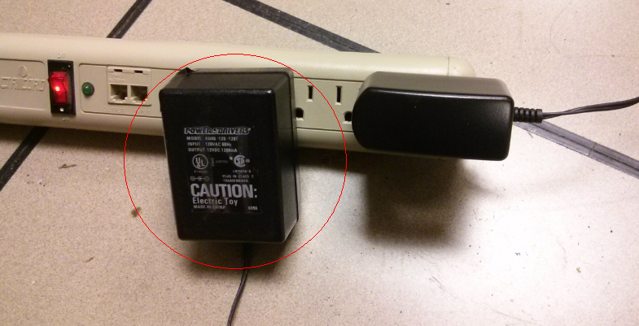

**How to use software :**

Here we use the windows 8.1 For the OS and Visual studio 2013 for application :

Also you need download and install [Latest Kinect for Windows SDK](http://go.microsoft.com/fwlink/?LinkID=323588) and [Latest Kinect for Windows Developer Toolkit](http://go.microsoft.com/fwlink/?LinkID=323589) at <http://www.microsoft.com/enus/kinectforwindowsdev/Downloads.aspx> before running the application

## **Run the software :**

Open visual studio 2013

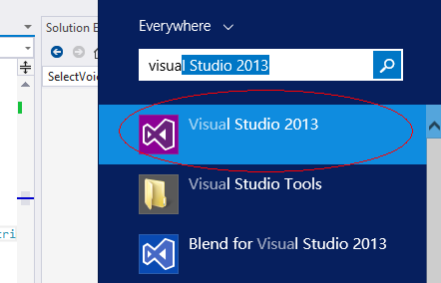

Choose file—open project—open the CountessQuantaControl.sln to load the applicaton

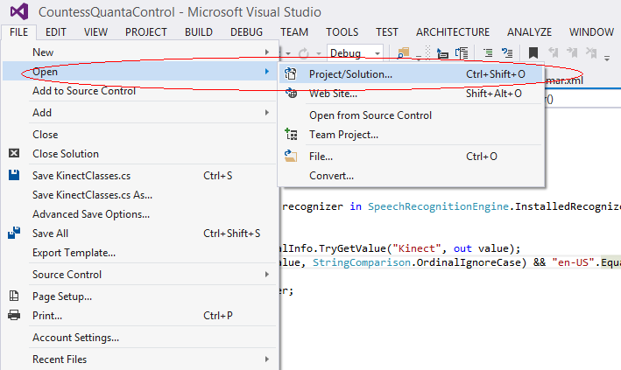

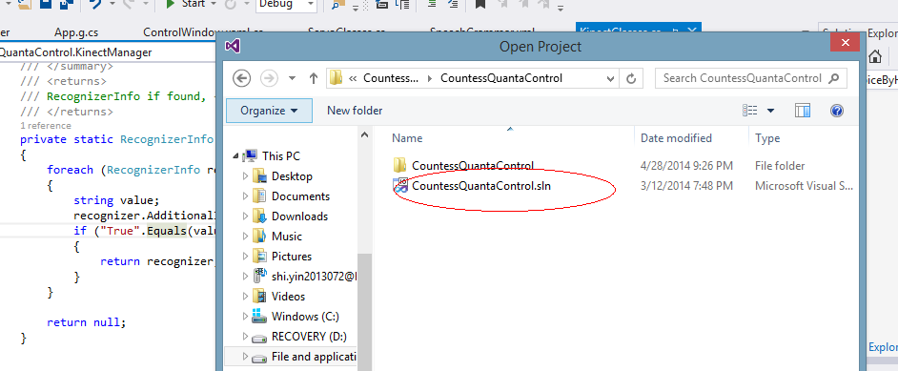

To run the application, press start button

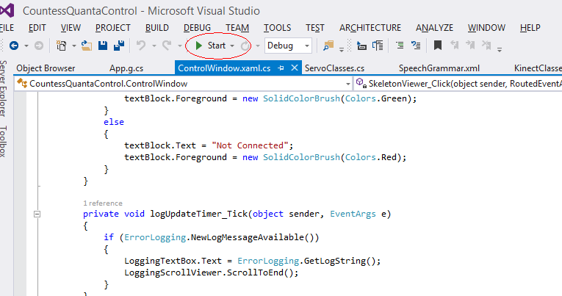

To As shown in the User Interface , the servo state and Kinect state indicate the state , the red “ not connected” means the item didn’t connect correctly , to resolve It, you should check whether the hardware connect correctly. If they connect correctly, the green” connected” will come out.

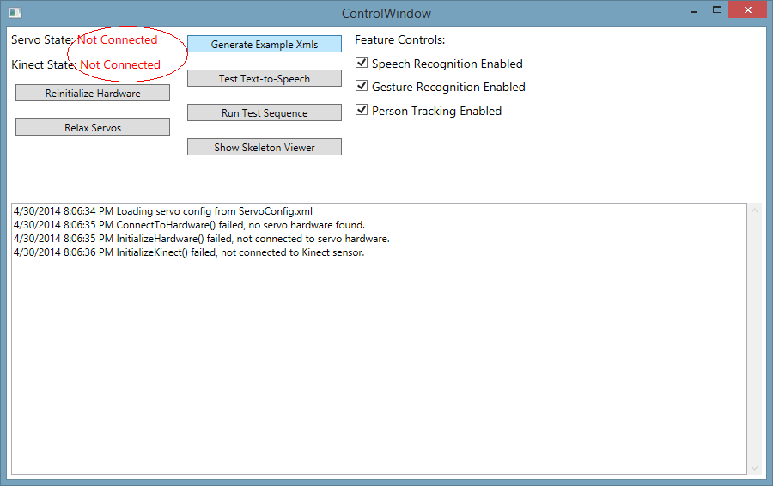You can press the button to do “reinitialize hardware” etc.

And also check the box to run the feature you want.

**Implement the scenario for the robot :**

This is the scenario diagram for the robot presently implemented.

The text here is what you speak to the robot

How are you doing

Hi

Hello

If you speak something robot didn’t recognize, she will reply with “ I didn’t get you and tell you an ancient motto

Randomly”

What’s your name

What’s one and two

Can you do some simple math calculation

That’s cool

Can you play some music

Can you count the number from one to five

What can you do for us

Can you introduce yourself

Can you do some gesture recognition

Next one

Next two

Five minus one

Good to meet you

thanks

Go ahead

Can you introduce the lab to us

You are smart

Next three

You are smart

see you

**Grammar for robot :**

Open the speechgrammar.xml file under CountessQuantaControl directory:

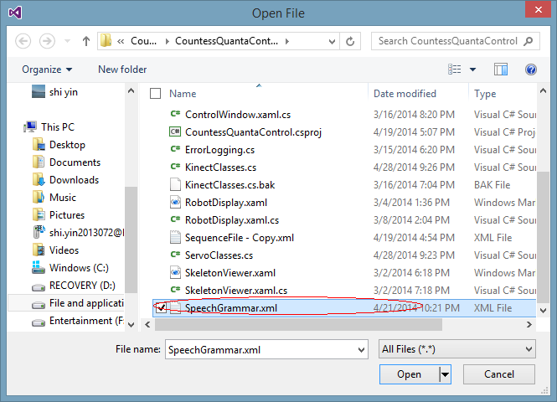

Example:

If you speak the word in the list, the application will all recognize as the word “thanks”, and you can feel free to add the item list you want.

<item>

<tag>Thanks</tag>

<one-of>

<item> That's ok </item>

<item> That's fine </item>

<item> That's cool </item>

<item> it's so cool </item>

<item> it's cool </item>

<item> it's nice </item>

<item> it's pretty cool </item>

<item> you are smart </item>

</one-of>

</item>

**Motion sequence for robots :**

Open the KinectClasses.cs file under CountessQuantaControl directory:

Under the speechRecognized method there is a case statement, also take the “thanks” as example, after the “ thanks “ be recognized by the application, it will goes to the case statement to check if “thanks “ is recognized, it will run the “thanks” motion sequence. You can add whatever case statement you want to connect the grammar with the motion sequence.

case "Thanks":

sequenceName = "Thanks";

break;

You can also change the value of confidnecethreshold to decide how much degree the robot will know the word human speak, the higher value, the higher degree human speak should match the grammar; that means you should speak more clearly and accurately;

const double ConfidenceThreshold = 0.5;

if (e.Result.Confidence >= ConfidenceThreshold)

{

string sequenceName = "";

switch (e.Result.Semantics.Value.ToString())

{

case "Hello":

sequenceName = "Hello";

break;

And if the actual confidence is lower than the threshold value, what means the robot will not recognize what human speak , it will turns to response an random ancient motto, in this example , there are five mottos and you can change to six by change rnd.Next(1,5) to rnd.Next(1,6), and add more “DEFAULT” sequence in the sequence motion xml to correspond to the new motto you added, we will talk about it next;

if (e.Result.Confidence < ConfidenceThreshold)

{

//fileno++;

Random rnd = new Random();

int fileno = rnd.Next(1, 5);

//srand(time(NULL));

//fileno =rand()%3+1;

string fileNoString=fileno.ToString();

string sequenceName= "DEFAULT" +fileNoString;

Open CountessQuantaControl\CountessQuantaControl\bin\Debug\SequenceFile.xml

Take the “thanks “ sequence as example again, while robot recognized it’s the “thanks” she heard, application will run the “thanks” sequence in the SequenceFile.xml in the Kinectclass.cs. the sequence as shown below:

Each sequence is composed of different motion frame, each frame have the state of servo number and position, and you can put the speech in each frame by edit speech =”text”; timetodestination is the parameter each frame will sustain.

</Sequence>

<Sequence Name=**"Thanks"**>

<Frame Name=**"Example Frame"** TimeToDestination=**"0.5"** Speech=**"thank you and I am happy"**>

<ServoPosition Index=**"11"** Position=**"1290"** />

<ServoPosition Index=**"3"** Position=**"2379"** />

</Frame>

<Frame Name=**"Example Frame"** TimeToDestination=**"0.5"** >

<ServoPosition Index=**"11"** Position=**"992"** />

<ServoPosition Index=**"3"** Position=**"2064"** />

</Frame>

<Frame Name=**"Example Frame"** TimeToDestination=**"0.5"** Speech=**"what else can I do for you today"**>

<ServoPosition Index=**"11"** Position=**"1290"** />

<ServoPosition Index=**"3"** Position=**"2379"** />

<ServoPosition Index=**"10"** Position=**"1104"** />

<ServoPosition Index=**"0"** Position=**"1350"** />

</Frame>

<Frame Name=**"Example Frame"** TimeToDestination=**"0.5"** >

<ServoPosition Index=**"11"** Position=**"992"** />

<ServoPosition Index=**"3"** Position=**"2064"** />

<ServoPosition Index=**"10"** Position=**"1760"** />

<ServoPosition Index=**"0"** Position=**"960"** />

</Frame>

<Frame Name=**"Example Frame"** TimeToDestination=**"0.5"** >

<ServoPosition Index=**"11"** Position=**"1290"** />

<ServoPosition Index=**"3"** Position=**"2379"** />

<ServoPosition Index=**"10"** Position=**"1104"** />

<ServoPosition Index=**"0"** Position=**"1350"** />

</Frame>

<Frame Name=**"Example Frame"** TimeToDestination=**"0.5"** >

<ServoPosition Index=**"11"** Position=**"992"** />

<ServoPosition Index=**"3"** Position=**"2064"** />

<ServoPosition Index=**"10"** Position=**"1760"** />

<ServoPosition Index=**"2"** Position=**"1400"** />

<ServoPosition Index=**"0"** Position=**"1350"** />

</Frame>

<Frame Name=**"Example Frame"** TimeToDestination=**"0.5"** >

<ServoPosition Index=**"11"** Position=**"1290"** />

<ServoPosition Index=**"3"** Position=**"2379"** />

<ServoPosition Index=**"2"** Position=**"2305"** />

<ServoPosition Index=**"0"** Position=**"960"** />

</Frame>

</Sequence>

You can also add Delay time to make certain amount of time delay.

<Sequence Name=**"Test Sequence"**>

<Frame Name=**"Example Frame 1"** TimeToDestination=**"1"** Speech=**"Testing one two three"** Delay=**"0.5"**>

<ServoPosition Index=**"0"** Position=**"800"** />

</Frame>

<Frame Name=**"Example Frame 2"** TimeToDestination=**"0.5"**>

<ServoPosition Index=**"0"** Position=**"2200"** />

</Frame>

<Frame Delay=**"2"**/>

<Frame Speech=**"Testing four five six."**/>

<Frame Delay=**"2"**/>

To add more random motto sequence we discuss before you can add more sequence name like from “DEFAULT1” to “DEFAULT6” to the file

<Sequence Name=**"DEFAULT3"**>

<Frame Name=**"Example Frame"** TimeToDestination=**"0.3"** Speech=**"sorry I didn't get you can you say it again"**>

<ServoPosition Index=**"11"** Position=**"1290"** />

<ServoPosition Index=**"8"** Position=**"1428"** />

<ServoPosition Index=**"0"** Position=**"1221"** />

<ServoPosition Index=**"2"** Position=**"1936"** />

<ServoPosition Index=**"3"** Position=**"2221"** />

</Frame>

**Change Servo default parameter:**

Open CountessQuantaControl\CountessQuantaControl\bin\Debug\ServoConfig.xml

As shown below you can change the servo parameter for each servo

<Servo>

<index>0</index>

<name>Wrist left/right</name>

<positionLimitMin>700</positionLimitMin>

<positionLimitMax>2300</positionLimitMax>

<speedLimitMin>10</speedLimitMin>

<speedLimitMax>1000</speedLimitMax>

<defaultPosition>1400</defaultPosition>

<defaultSpeed>20</defaultSpeed>

<defaultAcceleration>0</defaultAcceleration>

</Servo>

**Gesture recognition :**

In the kinectclass.cs you can add more gesture like” skel.Joints[JointType.HandRight].Position.Y > skel.Joints[JointType.Head].Position.Y”

And run the sequence “ hello” when do this gesture. The skeleton position is shown in <http://msdn.microsoft.com/en-us/library/jj131025.aspx#ID4EHE>

And this is all the positon joint

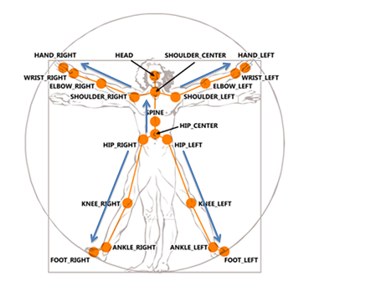

if (skeletons.Length != 0)

{

foreach (Skeleton skel in skeletons)

{

if (skel.TrackingState == SkeletonTrackingState.Tracked)

{

if (personTrackingEnabled)

{

sequenceProcessor.PersonTrackingUpdate(skel.Joints[JointType.Head].Position);

}

if (gestureRecognitionEnabled)

{

RightHandAboveHead.Evaluate(sequenceProcessor, skel.Joints[JointType.HandRight].Position.Y > skel.Joints[JointType.Head].Position.Y, "Hello");

**Also change some servos:**

Adjust the servo position for the neck so that the face of the robot can be up stand.

The servo for the mouth doesn’t work well.

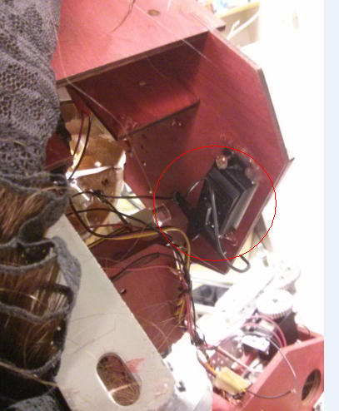

And the servo 3 doesn’t work well, also change the servo

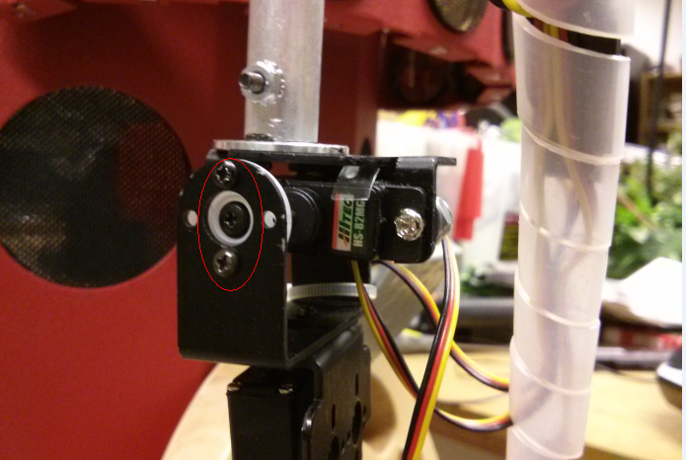

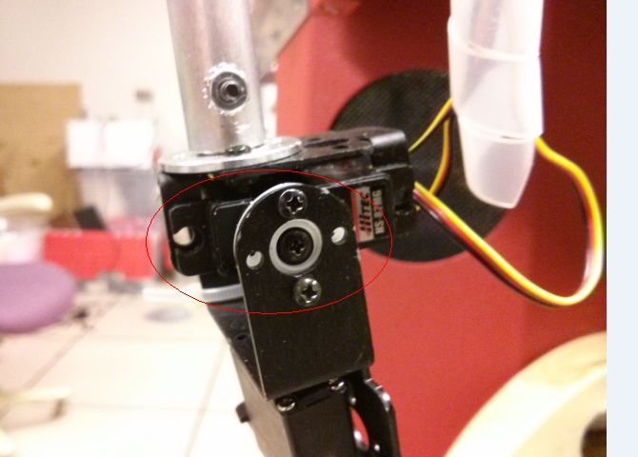

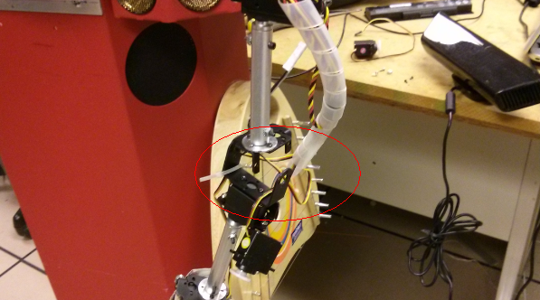

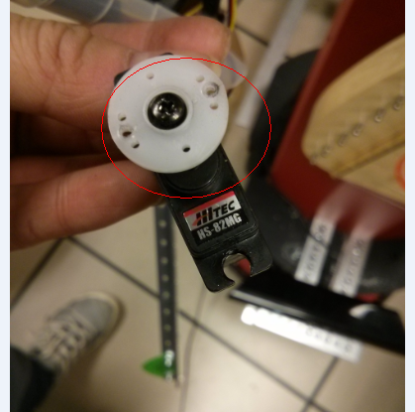

The servo 17 also didn’t work, change the servo

